Abstract
An abstract is required for submissions to the Health & Fitness Journal of Canada (with the exception of book reviews, editorials, and letters to the editor). All abstracts should be 250 words or less (including numbers, abbreviations, and symbols). Abstracts should be structured with Background: Purpose: Methods: Results: and Conclusion: sections. Reference citations are not permitted in the abstract. Six (6) to ten (10) key words should follow the abstract. These key words should not repeat phrases from the title. The abstract font type should be Cambria with a size 10 font. Authors can cut and paste from other word processing programs into this template. Please save your article as the first author et al with year of submission. Health & Fitness Journal of Canada 2019;XXX(X):X-XX.
https://doi.org/10.14288/hfjc.XXX.XXX
Keywords: Keyword One, Keyword Two, Keyword Three, Keyword Four, Keyword Five, Keyword Six
Introduction
In the introduction, the author(s) must introduce the topic and discuss its relevance. The author(s) must state clearly the purpose and hypothesis (where applicable) of the work. The introduction should be approximately 2-3 paragraphs and well cited. All papers that present original research findings must be hypothesis driven (i.e., contain a clearly defined hypothesis at the end of the introduction). Other papers (such as position papers, systematic reviews, narrative reviews, student opinions, etc.) should also include a brief 2-3 introduction highlighting the need for this work and the key hypotheses (as appropriate).

Methods
The strength of any manuscript is in the ability to reproduce the experimental conditions and findings. As such, sufficient detail must be provided in the methods section. A formal methods section should be included in the majority of articles (with the exception of book reviews, editorials, and letters to the editor)
In the methods section the author(s) must present clearly the topic information, describe the experimental conditions (where applicable), include written informed consent and ethical approval statements (where applicable), establish that the study adhered to the guidelines established by the Declaration of Helsinki (see example below), identify clearly the methods, equipment, and procedures utilized (with appropriate referencing), identify possible limitations in the experimental design and/or methodologies employed, identify clearly the statistical methods used (where applicable), denote statistical significance when present (where applicable), and provide sample size calculations (where appropriate).
Systematic reviews, meta-analyses, and narrative reviews should outline clearly the methodology employed. In the case of narrative reviews, a rationale should be provided for why a more systematic approach was not taken.
Below are example subsections of the methods section.

Participants
A total of X participants engaged in this research trial. All participants provided written informed consent and ethical approval was obtained from the University of XXX’s Clinical Ethics Research Board. The study adhered to the guidelines established by the Declaration of Helsinki.

Experimental Design
We carried out a randomized controlled trial examining the effects of …

Methodologies Employed
We examined the effects of a novel exercise intervention employing …

Results
It is important that the author(s) limit the results section to the questions posed in the introduction. This section should be concise, yet provide enough information for the reader to have a clear understanding of the key findings. The findings should be presented in the text, tables or figures. The presentation of the same data in tables and figures is not permitted. No discussion of the implications of the findings is required or permitted within the results section.

Tables and Figures
The tables should not duplicate the text or each other. Figures should be computer generated with clearly labelled axes and legends (see example Figure 1). Each figure and table should be given a title in numerical order according to its appearance within the text (e.g., Figure 1, Figure 2, etc.). Programs such as Microsoft Excel™ and Sigma Plot™ can be used and imported directly into this word template. All statistics must include mean and standard deviations. Statistically significant findings should be highlighted in all tables and figures using appropriate markers (such as *).
Authors are required to submit all materials in one single file (including text, figures, and references). Larger figure and tables can be formatted to go across the width of the page (see example). A font size of 10 should be used for table and figures. Please use SI units (International System of Units) throughout. Please make sure that the distance from surrounding text is at least 0.25 cm.
We have included an example Table template (see Table 1) for authors to use. This table is designed to move with the text. Each table should be located shortly after its first mention. All tables should have a title at the top in bold face with a font size of 10 pt (Cambria). Please follow the format provided in example Table 1.
Table 1: Participant characteristics (Mean ± SD).
Variable | Group 1 | Group 2 | Group 3 | Group 4
Age (yr) | 20 ± 5 | 24 ± 6 | 21 ± 6 | 22 ± 6
Height (cm) | 176 ± 5 | 180 ± 8 | 181 ± 7 | 177 ± 8
Weight (kg) | 70 ± 5 | 70 ± 7 | 71 ± 6 | 70 ± 6
Body Mass Index (kg/m²) | 23 ± 3 | 22 ± 4 | 22 ± 4 | 22 ± 4
Note: Place any special notes in this area including statistically significant findings (*, p < 0.05).
We have included an example Figure (from Shellington et al., 2018) that demonstrates the key features of figures. Please clearly label both axes with appropriate units. The title for each figure should be placed above the figure.
Discussion
This section should include a brief discussion of the results of the article. Results should be discussed as they relate to the available literature. This includes a well-referenced discussion of the findings in the context of other findings in the field. The discussion should be limited to the main contributions of the study to the field.
Figure 2: Mean reaction time (ms: top panel) and reaction time variability (ms: bottom panel) for pro- and antisaccades completed at baseline and post-intervention time points. Error bars represent 95% within-participant confidence intervals.

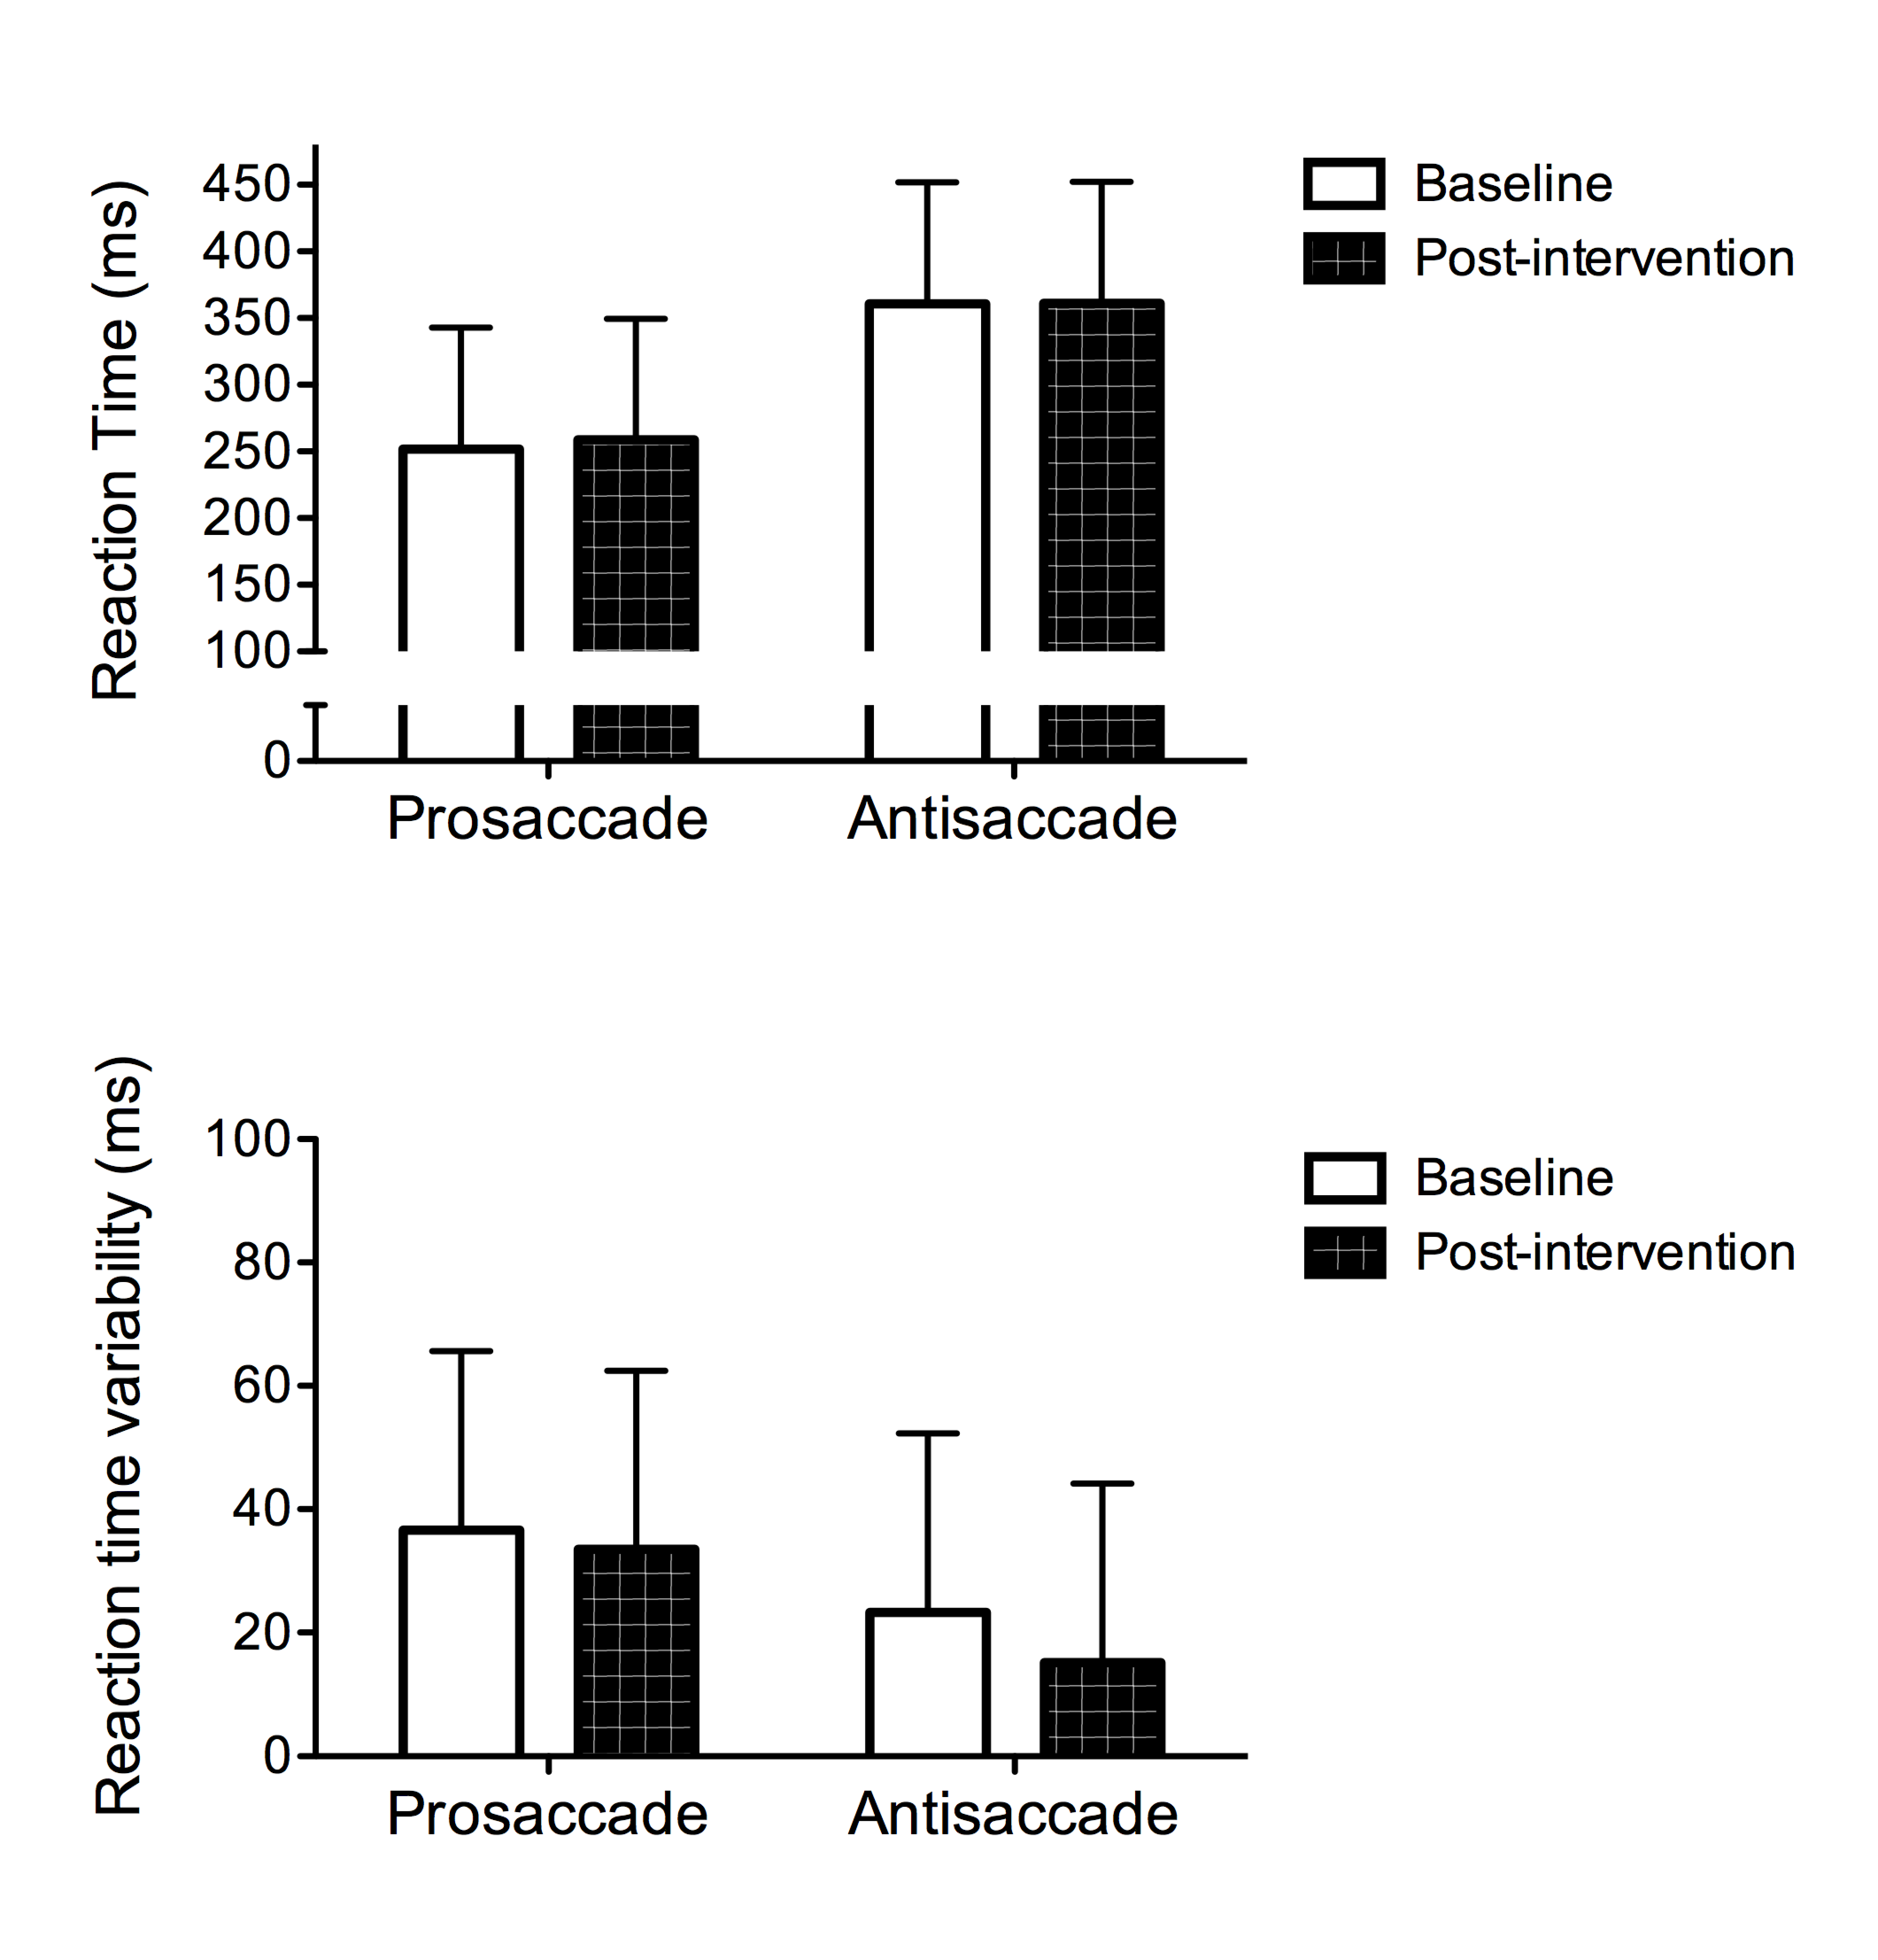

The first paragraph of the discussion should contain an outline of the innovative contributions of the work.

Conclusions
All manuscripts require a succinct summary statement regarding the overall conclusions of the work. The conclusions should summarize, but not repeat the findings of the discussion. All conclusions must be supported directly by the findings of the study.

Acknowledgements
Acknowledgements (written in third person) should recognize the contributions of individuals who contributed substantively to the paper but did not meet the minimal requirements for inclusion as a co-author (as outlined below).

Authors’ Qualifications
Each author is asked to provide a summary of his or her education and certifications. An example is provided:
The authors’ qualifications are as follows: Darren E. R. Warburton MSc, PhD, HFFC CEP Shannon S. D. Bredin MSc, PhD, HFFC CEP

References
Effective January 2019, the Health & Fitness Journal of Canada will make use of the APA 6th Edition referencing style. This format is similar to the referencing style used in previous years of our journal and will allow authors to more easily make use of referencing management software (such as Endnote, RefWorks, Mendeley, etc.). Some minor changes have been made to the recommendations APA 6th Edition referencing style. Specifically, for our journal we ask that all references are single spaced using Cambria 10-font. Also, each reference will be full justified using a hanging indent (see example).
The University of British Columbia Library has created a summary document that outlines the key features of the APA 6th Edition referencing style (http://ok-lib.sites.olt.ubc.ca/files/2014/08/APA-Guide-Fall-2013.pdf). We ask that all authors follow this template in their submission to expedite the review and publication process. Key features include:
- Hanging indents should be used for the reference list. All lines after the first line of each reference entry should be indented one half inch (1.27 cm) from the left margin (in Word 2010 use Format>Paragraph>Special>Hanging).
- Reference list is arranged in alphabetical order by the surname of the first author or by title if there is no author. Please use only the initials(s) of each author’s given name (not the full name) with a space between initals.
- When the reference list includes two or more articles by the same author(s), list these articles in chronological order (oldest first)
- Entries by the same author with the same year should be placed in alphabetical order by first letter of the title. A lower case letter (a, b, etc.) should be added after the year, within the parentheses.
- All references cited in the text must appear in the reference list (with the exception of personal communications).
Here is an example in-text citation and related reference list using the APA 6th Edition.

In-Text Citation Example

…(Calo et al., 2019; Monedero, McDonnell, Keoghan, & O’Gorman, 2014; The First Nations Information Governance Centre, 2018; Tremblay, Martin, McComber, McGregor, & Macaulay, 2018; Warburton & Bredin, 2018; Woodward et al., 2018).

Reference List Example

Calo, L., Martino, A., Tranchita, E., Sperandii, F., Guerra, E., Quaranta, F., . . . Pigozzi, F. (2019). Electrocardiographic and echocardiographic evaluation of a large cohort of peri-pubertal soccer players during pre-participation screening. Eur J Prev Cardiol, 2047487319826312. doi:10.1177/2047487319826312
Monedero, J., McDonnell, A. C., Keoghan, M., & O’Gorman, D. J. ( 2014). Modified active videogame play results in moderate-intensity exercise. Games Health J, 3, 234–240. doi:10.1089/g4h.2013.0096
The First Nations Information Governance Centre. (2018). The First Nations Principles of OCAP®. Retrieved from https://fnigc.ca/ocapr.html
Tremblay, M. C., Martin, D. H., McComber, A. M., McGregor, A., & Macaulay, A. C. (2018). Understanding community-based participatory research through a social movement framework: a case study of the Kahnawake Schools Diabetes Prevention Project. BMC Public Health, 18(1), 487. doi:10.1186/s12889-018-5412-y
Warburton, D. E. R., & Bredin, S. S. D. (2018). Lost in Translation: What does the physical activity and health evidence actually tell us? In S. Zibadi & R. R. Watson (Eds.), Lifestyle in Heart Health and Disease (pp. 175-186). San Diego, CA: Elsevier.
Woodward, M. L., Gicas, K. M., Warburton, D. E., White, R. F., Rauscher, A., Leonova, O., . . . Lang, D. J. (2018). Hippocampal volume and vasculature before and after exercise in treatment-resistant schizophrenia. Schizophr Res, 202, 158-165. doi:10.1016/j.schres.2018.06.054

General Style and Formatting Details
- Please use this template to directly compose your article. This will facilitate the timely publication of accepted articles.
- The manuscript must be single-spaced using Cambria 12-point font, employing italics (rather than underlining (except with URL addresses). The manuscript must be in a Microsoft Word, RTF, or WordPerfect document file format, and not a PDF format.
- The manuscript should have left and right margins of 1 inch (2.54 cm) and be single-spaced throughout. All illustrations, figures, and tables must be placed within the text at the appropriate points, rather than at the end. A title should be placed above all illustrations, figures, and tables.
- Please submit one file containing the complete text, references, figures, and tables.
- The font size will vary depending on the article component. Main text and headings (including sub-headings) should be at a font size of 12 pt. Tables, figures and abstracts should be at a font size of 10. Smaller font may be permitted in tables or figures depending on the article.
- The main body of the text and references should be full justified.
- All articles should have a Title Page, Introduction, and Conclusion with appropriate references.
- All manuscripts (other than books reviews, editorials, and letters to the editor) must contain a title page, an abstract, an introduction, methodology, results, discussion, conclusions, acknowledgements, qualifications (of authors), and references. All pages (including the title page) should be numbered consecutively.
- Main Headings (Introduction, Methods, Results, Discussion, Conclusions, Acknowledgements, Authors’ Qualifications, References) should start at the far left margin in bold font. Sub-headings should be italicized starting at the far left margin in bold font.
- All paragraphs should start with a brief indent (0.5 cm, see example).
- English is the language of publication for this journal. Authors who speak English as a second language are encouraged to get assistance from someone with expertise in writing in English and publishing in English-language scientific journals.
- Authors are required to use non-sexist language (see American Psychologist 30:682-684, 1975). Authors should avoid the excessive usage of acronyms. It is recommended that up to three acronyms be used per manuscript. All acronyms should be defined upon first appearance in the text.
- The title page should contain:
  - The full title of the paper.
  - All authors (full names) listed in the desired order of appearance on the printed work.
  - The name and contact email information for the corresponding author.
  - The institutional affiliation(s) for each author as established by the use of corresponding superscript numbers.
- A running title consisting of no more than 60 characters (including spaces) should be included after the title page.

Authorship Requirements
The Health & Fitness Journal of Canada has established authorship requirements that are consistent with the field and manuscripts sent to biomedical journals. For an individual to be included on a paper they must have participated sufficiently in the work to take responsibility for the content of the manuscript. Authors must also have 1) played a significant role in the writing and/or revision of the manuscript, 2) made significant contributions to the conception and design of the study and/or the interpretation of the data, and 3) provided final approval of the version to be published. Others that contributed to the work may be included in the acknowledgements.
It is important to highlight that the collection of data, the general supervision of data collection, and/or the acquisition of funding does not justify authorship. Individuals who received remuneration for their work also are not required to be listed as co-authors. The authors determine the order of authorship.

