Abstract
An abstract is required for submissions to the Health & Fitness Journal of Canada (except for book reviews, editorials, and letters to the editor). All abstracts should be 250 words or less (including numbers, abbreviations, and symbols). Abstracts should be structured with Background: Purpose: Methods: Results: and Conclusion: sections. Reference citations are not permitted in the abstract. Six (6) to ten (10) key words should follow the abstract. These key words should not repeat phrases from the title. The abstract font type should be Cambria with a size 10 font. Authors can cut and paste from other word processing programs into this template. Please save your article as the first author et al with year of submission (e.g., Smith et al 2026.docx).
Health & Fitness Journal of Canada 2026;XXX(X):X-XX.
https://doi.org/10.14288/hfjc.XXX.XXX
Keywords: Keyword One, Keyword Two, Keyword Three, Keyword Four, Keyword Five, Keyword Six

Introduction
In the introduction, the author(s) must introduce the topic and discuss its relevance. The author(s) must state clearly the purpose and hypothesis (where applicable) of the work. The introduction should be approximately 2-3 paragraphs and well cited. All papers that present original research findings must be hypothesis driven (i.e., contain a clearly defined hypothesis at the end of the introduction). Other papers (such as position papers, systematic reviews, narrative reviews, student opinions, etc.) should also include a brief highlighting the need for this work and the key hypotheses (as appropriate).

Methods
The strength of any manuscript is in the ability to reproduce the experimental conditions and findings. As such, sufficient detail must be provided in the methods section. A formal methods section should be included in most articles (except for book reviews, editorials, and letters to the editor).
In the methods section the author(s) must present clearly the topic information, describe the experimental conditions (where applicable), include written informed consent and ethical approval statements (where applicable), establish that the study adhered to the guidelines established by the Declaration of Helsinki (see example below), identify clearly the methods, equipment, and procedures utilized (with appropriate referencing), identify possible limitations in the experimental design and/or methodologies employed, identify clearly the statistical methods used (where applicable), denote statistical significance when present (where applicable), and provide sample size calculations (where appropriate).
Systematic reviews, meta-analyses, and narrative reviews should outline clearly the methodology employed. In the case of narrative reviews, a rationale should be provided for why a more systematic approach was not taken. Below are example subsections of the methods section.

Participants
A total of X participants engaged in this research trial. All participants provided written informed consent, and ethical approval was obtained from the University of XXX’s Clinical Ethics Research Board. The study adhered to the guidelines established by the Declaration of Helsinki.

Experimental Design
We carried out a randomized controlled trial examining the effects of …

Methodologies Employed
We examined the effects of a novel exercise intervention employing …

Results
It is important that the author(s) limit the results section to the questions posed in the introduction. This section should be concise yet provide enough information for the reader to have a clear understanding of the key findings. The findings should be presented in the text, tables or figures. The presentation of the same data in tables and figures is not permitted. No discussion of the implications of the findings is required or permitted within the results section.

Tables and Figures
The tables should not duplicate the text or each other. Figures should be computer-generated with clearly labelled axes and legends (see example Figure 1). Each figure and table should be given a title in numerical order according to its appearance within the text (e.g., Figure 1, Figure 2, etc.). Programs such as Microsoft Excel™ and Sigma Plot™ can be used and imported directly into this word template. All statistics must include mean and standard deviations. Statistically significant findings should be highlighted in all tables and figures using appropriate markers (such as *).
Authors are required to submit all materials in one single file (including text, figures, and references). Larger figures and tables can be formatted to go across the width of the page (see example). A font size of 10 should be used for tables and figures. Please use SI units (International System of Units) throughout. Please make sure that the distance from surrounding text is at least 0.25 cm.
We have included an example Table template (see Table 1) for authors to use. This table is designed to move with the text. Each table should be located shortly after its first mention. All tables should have a title at the top in bold face with a font size of 10 pt Cambria.
Figure 1: Mean reaction time (ms: top panel) and reaction time variability (ms: bottom panel) for pro- and antisaccades completed at baseline and post-intervention time points. Error bars represent 95% within-participant confidence intervals.

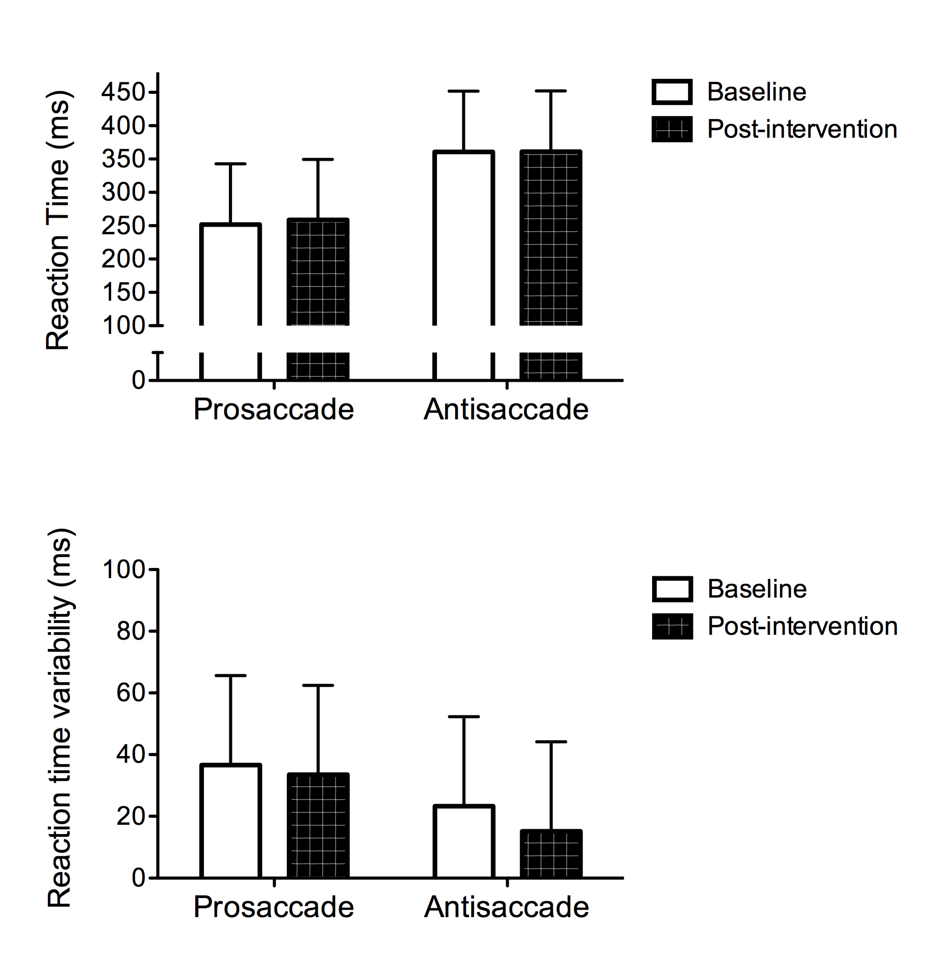

Table 1: Participant characteristics (Mean ± SD).
Variable | Group 1 | Group 2 | Group 3 | Group 4
Age (yr) | 20 ± 5 | 24 ± 6 | 21 ± 6 | 22 ± 6
Height (cm) | 176 ± 5 | 180 ± 8 | 181 ± 7 | 177 ± 8
Weight (kg) | 70 ± 5 | 70 ± 7 | 71 ± 6 | 70 ± 6
Body Mass Index (kg⋅m⁻²) | 23 ± 3 | 22 ± 4 | 22 ± 4 | 22 ± 4
Note: Place any special notes in this area including significant findings (*, p < 0.05).
We have included an example Figure 1 that demonstrates the key features of figures. Please clearly label both axes with appropriate units (Shellington et al., 2018). The title for each figure should be placed above the figure.

Discussion
This section should include a brief discussion of the results of the article. Results should be discussed as they relate to the available literature. This includes a well-referenced discussion of the findings in the context of other findings in the field. The discussion should be limited to the main contributions of the study to the field. The first paragraph of the discussion should contain an outline of the innovative contributions of the work.
Conclusions
All manuscripts require a succinct summary statement regarding the overall conclusions of the work. The conclusions should summarize but not repeat the findings of the discussion. All conclusions must be supported directly by the findings of the study.

Acknowledgements
Acknowledgements (written in third person) should recognize the contributions of individuals who contributed substantively to the paper but did not meet the minimal requirements for inclusion as a co-author (as outlined below).

Authors’ Qualifications
Each author is asked to provide a summary of his or her education and certifications. An example is provided:
The authors’ qualifications are as follows: Darren E. R. Warburton MSc, PhD, HFFC CEP; Shannon S. D. Bredin MSc, PhD, HFFC CEP.

AI Use Statement
All articles must include an “AI Use Statement” including:
- Tool(s) used: (name and version, if available).
- Purpose of use: (e.g., language editing, summarization, code assistance, figure generation).
- Extent of use: (which sections/elements were supported).
- Human oversight: brief description of how authors verified accuracy, originality, and sources.
- Data privacy: confirmation that no confidential, proprietary, or identifiable participant data were entered into AI tools unless permitted by ethics and privacy requirements.

Example AI Use Statement
“AI-assisted tools (ChatGPT, OpenAI, accessed Month Year) were used to improve grammar and readability of the Introduction and Discussion. All scientific content, interpretations, and conclusions were developed by the authors, who reviewed and verified all edits. No identifiable participant information was entered into the tool.”
OR
“No AI or automated tools were used in the preparation of this manuscript.”

References
The Health & Fitness Journal of Canada makes use of the APA 7th Edition referencing style. This format is similar to the referencing style used in previous years of our journal and will allow authors to more easily use referencing management software (such as Endnote, RefWorks, Mendeley, etc.). The University of British Columbia Library has created a guideline that outlines the key features of the APA 7th Edition referencing style (https://guides.library.ubc.ca/apacitationstyle). We ask that all authors follow our article template in their submission to expedite the review and publication process. Minor changes have been made to the recommendations APA 7th Edition referencing style.
Key reference features include:
- Hanging indents should be used for the reference list. All lines after the first line of each reference entry should be indented one-half inch (1.27 cm) from the left margin (in Word use Format>Paragraph>Special>Hanging).
- Reference list is arranged in alphabetical order by the surname of the first author or by title if there is no author. Please use only the initials(s) of each author’s given name (not the full name) with a space between initials.
- When the reference list includes two or more articles by the same author(s), list these articles in chronological order (oldest first).
- Entries by the same authors with the same year should be placed in alphabetical order by first letter of the title. A lower-case letter (a, b, etc.) should be added after the year, within the parentheses.
- All references cited in the text must appear in the reference list (except for personal communications).
Here is an example in-text citation and related reference list using the APA 7th Edition.

In-Text Citation Example
… (Benji et al., 2021; Calo et al., 2019; First Nations Health Authority, 2018; Foulds et al., 2018a, 2018b; Miles et al., 2023; The First Nations Information Governance Centre, 2018).

Reference List Example
Benji, J., Tomasky, G., Kaufman, K., & Miles, R. (2021). Impacts of COVID-19 on Indigenous Communities in Canada. Health & Fitness Journal of Canada, 14(4), 22–34. https://doi.org/10.14288/hfjc.v14i4.358
Calo, L., Martino, A., Tranchita, E., Sperandii, F., Guerra, E., Quaranta, F., Parisi, A., Nigro, A., Sciarra, L., Ruvo, E., Casasco, M., & Pigozzi, F. (2019). Electrocardiographic and echocardiographic evaluation of a large cohort of peri-pubertal soccer players during pre-participation screening. Eur J Prev Cardiol, 2047487319826312. https://doi.org/10.1177/2047487319826312
First Nations Health Authority. (2018). First Nations Health Authority: Governance and Accountability. First Nations Health Authority. Retrieved August 23, 2018 from http://www.fnha.ca/about/governance-and-accountability
Foulds, H. J. A., Bredin, S. S. D., & Warburton, D. E. R. (2018a). Cardiovascular dynamics of Canadian Indigenous peoples. Int J Circumpolar Health, 77(1), 1421351. https://doi.org/10.1080/22423982.2017.1421351
Foulds, H. J. A., Bredin, S. S. D., & Warburton, D. E. R. (2018b). Ethnic differences in vascular function and factors contributing to blood pressure. Can J Public Health, 109(3), 316–326. https://doi.org/10.17269/s41997-018-0076-z
Miles, R. M., Bredin, S. S. D., Kaufman, K., Lai, H., Robinson, D., Warburton, D., Horn Miller, W., & Warburton, D. (2023). Culturally and traditionally appropriate primary and secondary cardiometabolic disease prevention in Indigenous peoples: A strengths-based approach. Health & Fitness Journal of Canada, 16(1), 24–45.
Shellington, E. M., Heath, M., Petrella, A. F. M., Gill, D. P., & Petrella, R. J. (2018). A six-month study of antisaccade reaction time in elderly adults with cognitive impairment in a retirement living home: A Mind Fun sub-study.: Antisaccade reaction time in elderly adults. The Health & Fitness Journal of Canada, 11(3), 3–11. https://doi.org/10.14288/hfjc.v11i3.262
The First Nations Information Governance Centre. (2018). The First Nations Principles of OCAP®. The First Nations Information Governance Centre. Retrieved August 20, 2018 from https://fnigc.ca/ocapr.html

General Style and Formatting Details

Use the journal template
- Please write your manuscript directly in this template to support timely review and publication.

File type
- Submit your manuscript as one file in Microsoft Word (.doc/.docx), RTF, or WordPerfect format.
- Do not submit PDFs.

Page layout
- Margins: 1 inch (2.54 cm) on right and left sides.
- Line spacing: single-spaced throughout
- Font: Cambria
  - Main text and headings: 12 pt
  - Abstract, references, tables, and figure text: 10 pt (smaller may be used in tables/figures if needed for fit and readability)

Text formatting
- Use italics (do not underline), except for URLs.
- The main text and references must be fully justified.
- Paragraph indent: 0.5 cm for each new paragraph.

Headings
- Main headings (e.g., Introduction, Methods, Results, Discussion, Conclusions, Acknowledgements, Authors’ Qualifications, References):
  - Bold, start at the left margin.
- Sub-headings:
  - Bold italic, start at the left margin.

Figures and tables
- Place all figures and tables within the text at the appropriate location (not at the end).
- Each figure/table must include a title above it.

Page numbers
- Number all pages consecutively, starting with the title page beginning with page 1. You do not need to change the footer.

Required Manuscript Sections

All submissions must include
- Title Page
- Introduction
- Conclusion
- References

Research articles (all manuscripts except book reviews, editorials, and letters)
Must include:
- Title Page
- Abstract
- Introduction
- Methodology
- Results
- Discussion
- Conclusions
- Acknowledgements
- Authors’ Qualifications
- References

Language and style expectations
- Language of publication: English. Authors writing in English as a second language are encouraged to seek editorial support prior to submission.
- Use non-sexist language (see American Psychologist, 30, 682–684, 1975).
- Avoid excessive acronyms; recommended maximum is three acronyms per manuscript and define all acronyms at first use.

Title page requirements
The title page must include:
- Full title of the paper
- All authors (full names), listed in the desired order of appearance
- Corresponding author name and email
- Institutional affiliations for each author, indicated using superscript numbers

Running title
- Include a running title (maximum 60 characters, including spaces) after the title page.

Authorship Requirements
The Health & Fitness Journal of Canada has established authorship requirements that are consistent with the field and manuscripts sent to biomedical journals. For an individual to be included on a paper they must have participated sufficiently in the work to take responsibility for the content of the manuscript. Authors must also have 1) played a significant role in the writing and/or revision of the manuscript, 2) made significant contributions to the conception and design of the study and/or the interpretation of the data, and 3) provided final approval of the version to be published. Others that contributed to the work may be included in the acknowledgements section.
It is important to highlight that the collection of data, the general supervision of data collection, and/or the acquisition of funding does not justify authorship. Individuals who received remuneration for their work also are not required to be listed as co-authors. The authors determine the order of authorship.

